Circumcircle as a Locus

Definition
# Source: AI Source: Provided by: [Data Path: Persons Table -> ID Column: 1, Name_En Column: Motasem Essam] -> From: [ChatGPT] on [7/25/2026]
The circumcircle as a locus is the locus of points that are equally distant from the vertices of a given triangle.
For a triangle $△ABC$, the circumcircle is the circle passing through $A$, $B$, and $C$. Its center is the circumcenter $O$, which is equidistant from all three vertices:
$$\boxed{OA=OB=OC=R}$$
where $R$is the circumradius.
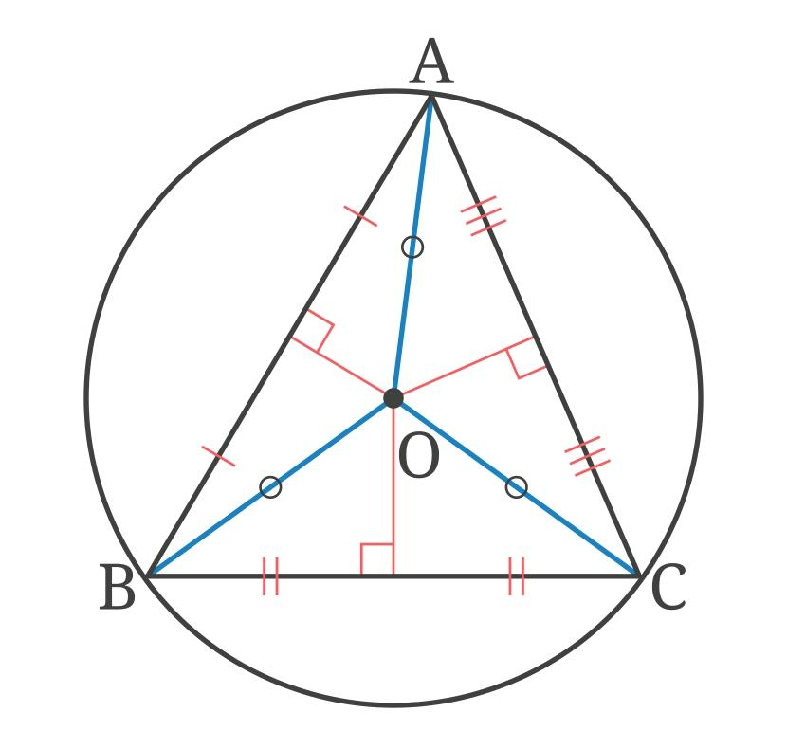
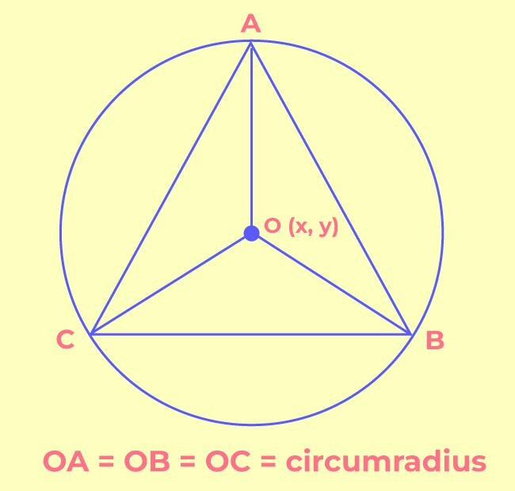
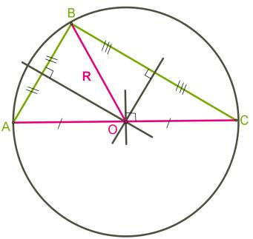
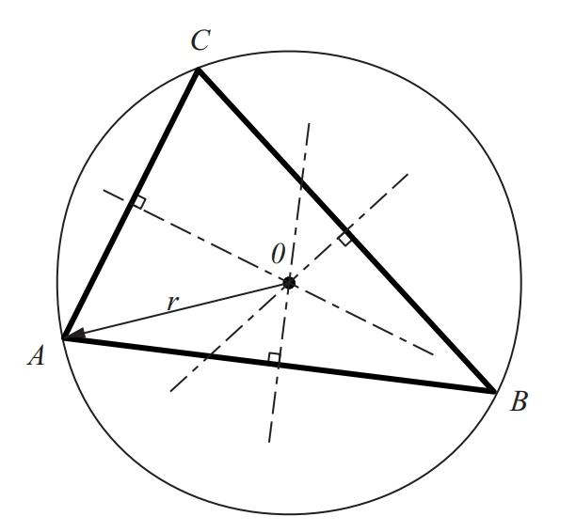
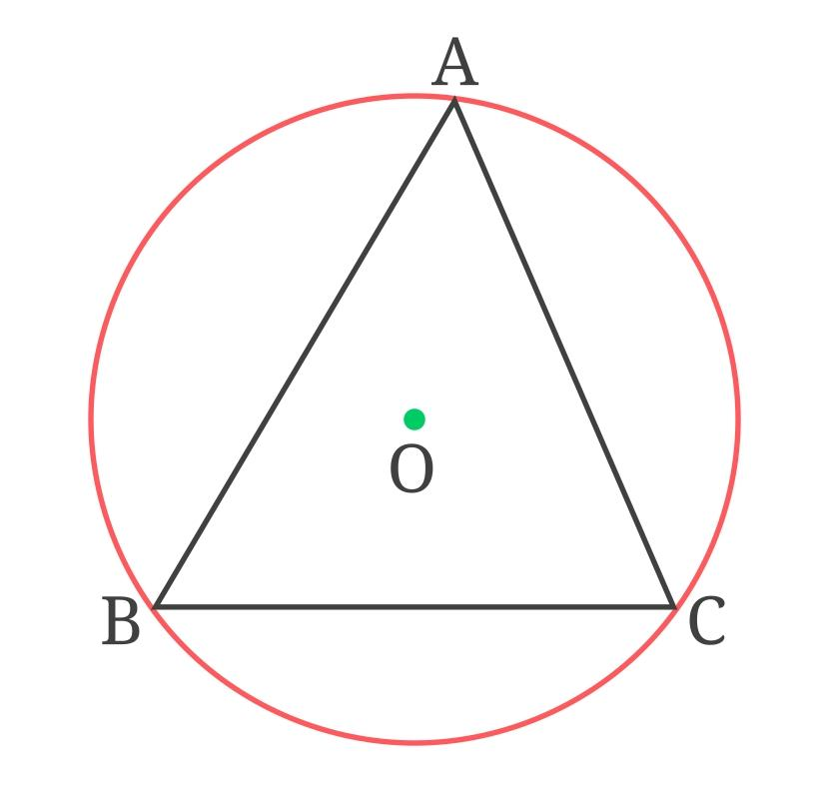

Simple Definition
# Source: AI Source: Provided by: [Data Path: Persons Table -> ID Column: 1, Name_En Column: Motasem Essam] -> From: [ChatGPT] on [7/25/2026]
The circumcircle is the circle that passes through all three vertices of a triangle.
From the locus viewpoint:
It is the set of all points at a fixed distance $R$from the circumcenter $O$.
Thus:
$$\boxed{P\text{ lies on the circumcircle }⟺ OP=R}$$

Fundamental Concept
# Source: AI Source: Provided by: [Data Path: Persons Table -> ID Column: 1, Name_En Column: Motasem Essam] -> From: [ChatGPT] on [7/25/2026]
Consider $△ABC$.
There is a unique point $O$, called the circumcenter, satisfying
$$OA=OB=OC.$$
Therefore, $A$, $B$, and $C$all lie at the same fixed distance from $O$.
The circle centered at $O$with radius $R=OA$passes through all three vertices.
Hence:
$$\boxed{OA=OB=OC=R→\text{Circumcircle of }△ABC}$$
The circumcircle is therefore a special case of the general locus:
$$\boxed{\text{Fixed distance from a fixed point}→\text{Circle}}$$

Circumcircle of a Triangle
# Source: AI Source: Provided by: [Data Path: Persons Table -> ID Column: 1, Name_En Column: Motasem Essam] -> From: [ChatGPT] on [7/25/2026]
For a nondegenerate triangle $△ABC$, its circumcircle is the unique circle passing through
$$A, B, C.$$
If $O$is the circumcenter:
$$\boxed{OA=OB=OC=R}.$$
The circle is commonly denoted by
$$\boxed{\left(O , R\right)}$$
or described as the circumcircle of $△ABC$.
Example
Suppose
$$A, B, C$$
are three non-collinear points.
Construct the perpendicular bisector of $AB$and the perpendicular bisector of $AC$. Their intersection is $O$.
Then
$$OA=OB=OC.$$
Drawing the circle centered at $O$through $A$gives the circumcircle.
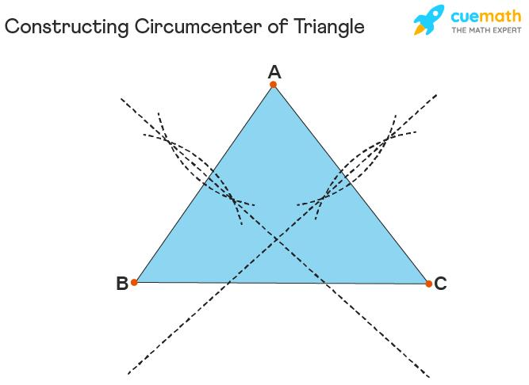
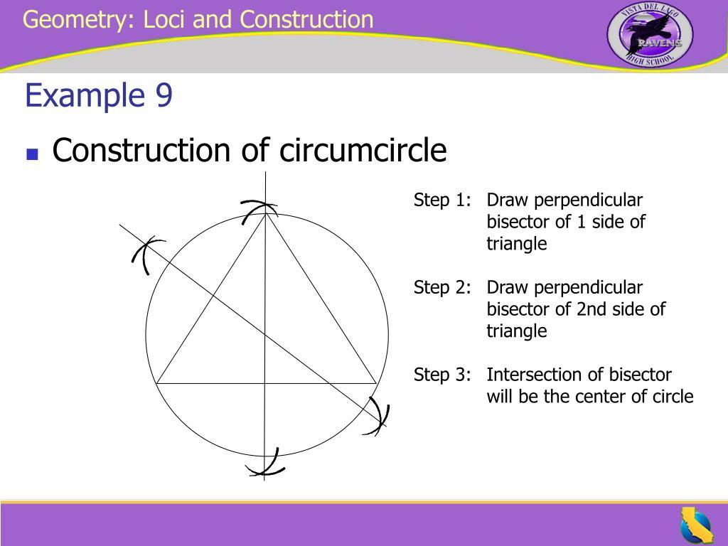
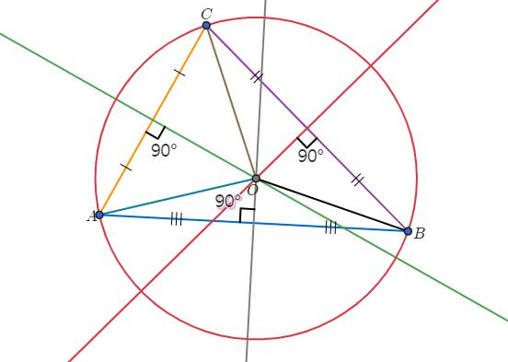
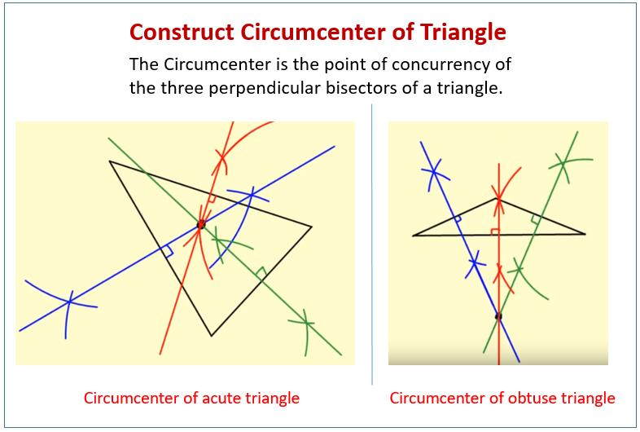

Circumcircle as a Fixed-Distance Locus
# Source: AI Source: Provided by: [Data Path: Persons Table -> ID Column: 1, Name_En Column: Motasem Essam] -> From: [ChatGPT] on [7/25/2026]
Once the circumcenter $O$and circumradius $R$are known, every point $P$on the circumcircle satisfies
$$\boxed{OP=R}.$$
Therefore:
$$\boxed{\text{Circumcircle}=\left\{P:OP=R\right\}}$$
This is exactly the locus of points at a fixed distance $R$from $O$.
Example
If
$$O=\left(2 , 3\right)$$
and
$$R=5,$$
then the circumcircle is
$$\boxed{{\left(x-2\right)}^{2}+{\left(y-3\right)}^{2}=25}.$$
Every point $P=\left(x , y\right)$satisfying this equation belongs to the circumcircle.

Circumcenter as an Equidistance Locus
# Source: AI Source: Provided by: [Data Path: Persons Table -> ID Column: 1, Name_En Column: Motasem Essam] -> From: [ChatGPT] on [7/25/2026]
The circumcircle itself is a fixed-distance locus, but its center is obtained using equidistance loci.
For points $A$and $B$:
$$PA=PB$$
has the perpendicular bisector of $AB$as its locus.
Therefore, the circumcenter $O$must lie on the perpendicular bisector of $AB$:
$$OA=OB.$$
Similarly,
$$OA=OC$$
means that $O$lies on the perpendicular bisector of $AC$.
Thus:
$$\boxed{O=\text{intersection of two perpendicular bisectors}}$$
and automatically
$$\boxed{OA=OB=OC}.$$

The Three Perpendicular Bisectors
# Source: AI Source: Provided by: [Data Path: Persons Table -> ID Column: 1, Name_En Column: Motasem Essam] -> From: [ChatGPT] on [7/25/2026]
For $△ABC$, construct:
- perpendicular bisector of $AB$
- perpendicular bisector of $BC$
- perpendicular bisector of $CA$
All three intersect at the same point $O$.
This point is the circumcenter.
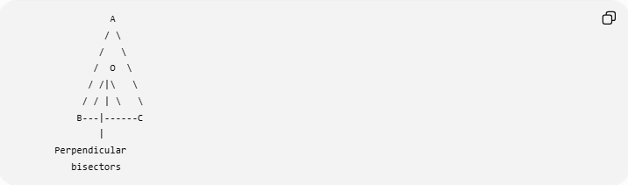
A
/ \
/ \
/ O \
/ /|\ \
/ / | \ \
B---|------C
|
Perpendicular
bisectors
Therefore:
$$\boxed{OA=OB=OC}.$$
Only two perpendicular bisectors are normally needed to locate $O$; the third passes through the same point.

Circumcircle and the Three Vertices
# Source: AI Source: Provided by: [Data Path: Persons Table -> ID Column: 1, Name_En Column: Motasem Essam] -> From: [ChatGPT] on [7/25/2026]
The three vertices of the triangle lie on the circumcircle:
$$\boxed{A,B,C∈\text{Circumcircle}}.$$
Consequently,
$$OA=OB=OC=R.$$
The sides
$$AB, BC, CA$$
are chords of the circumcircle.
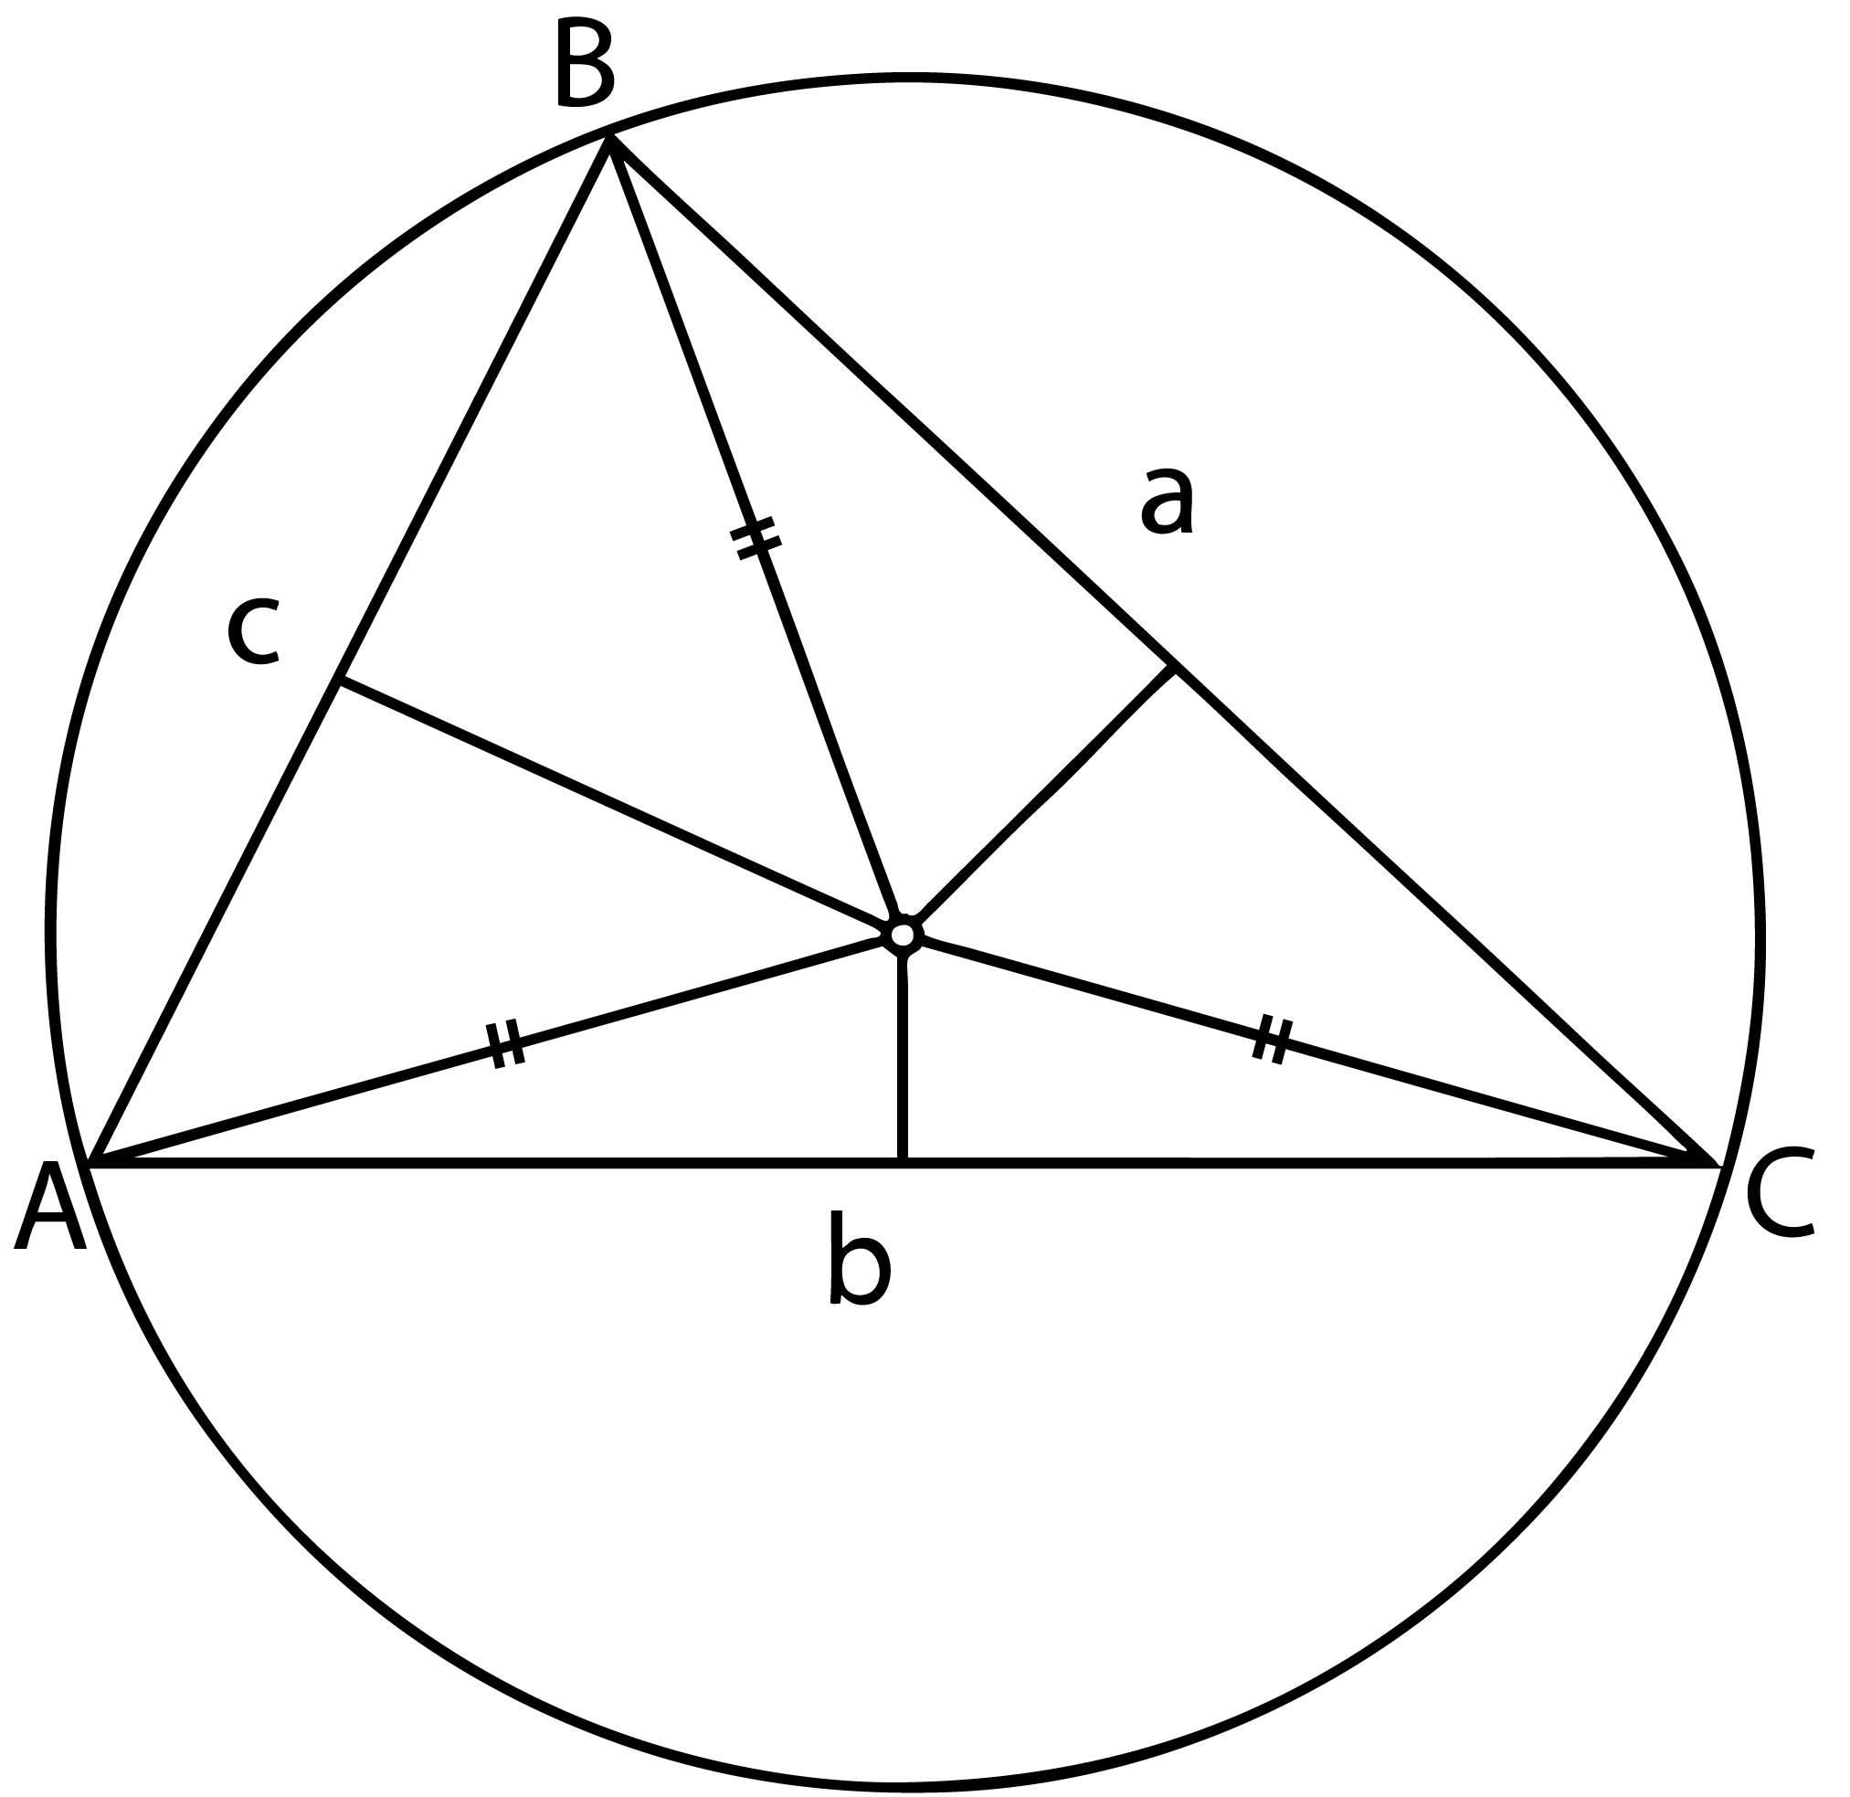
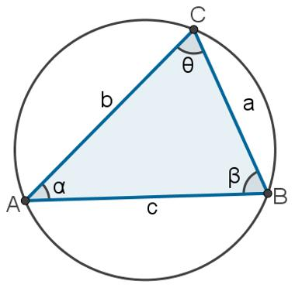
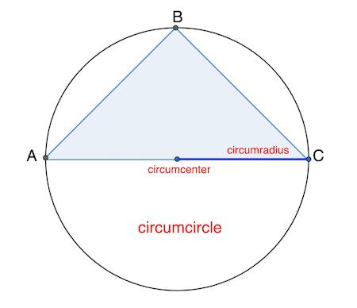
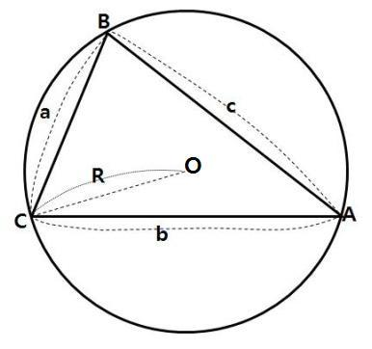
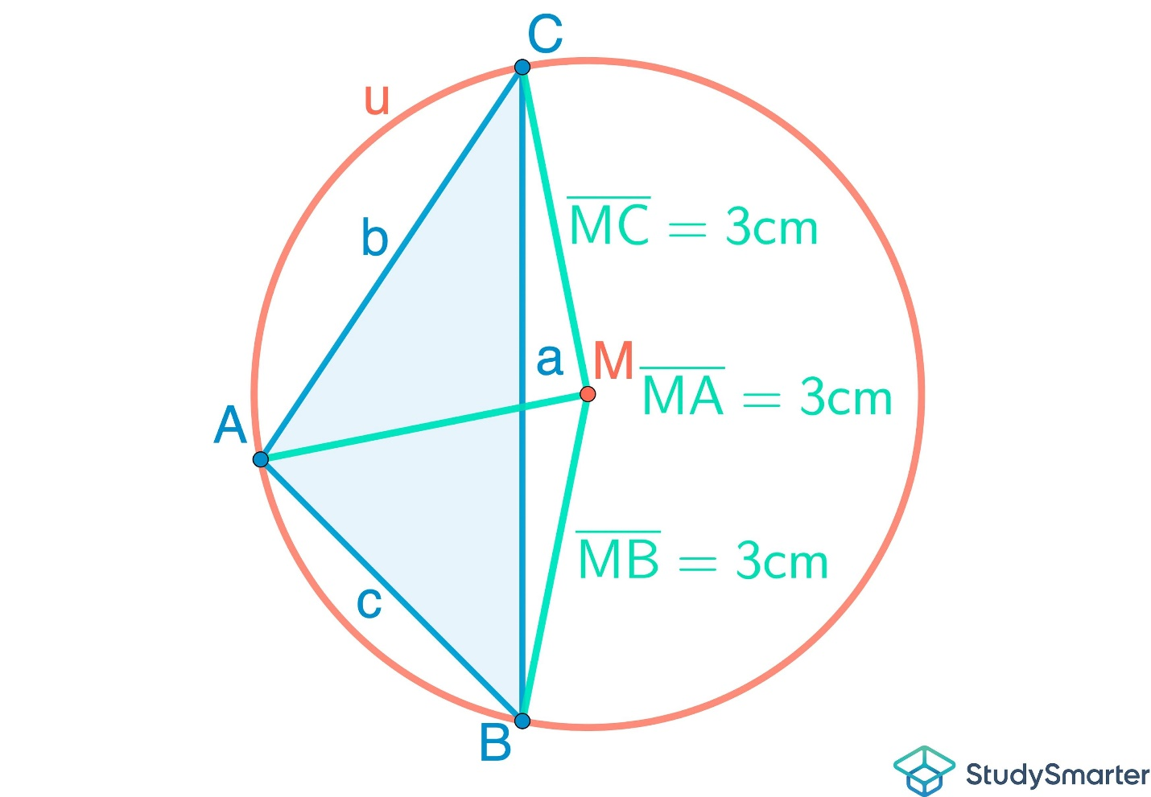

Circumcircle and the Fixed-Angle Locus
# Source: AI Source: Provided by: [Data Path: Persons Table -> ID Column: 1, Name_En Column: Motasem Essam] -> From: [ChatGPT] on [7/25/2026]
The circumcircle is closely related to the fixed-angle locus.
If $A$and $B$are fixed points on a circle and $P$moves along the appropriate arc, then
$$∠APB$$
remains constant.
This follows from the Inscribed Angle Theorem:
$$\boxed{m∠APB=\frac{1}{2}m\hat{AB}}$$
Therefore, a circumcircle can also be viewed as containing fixed-angle loci associated with its chords.
For example, if $AB$is a chord, all points $P$on the same appropriate arc see $AB$under the same angle.

Circumcircle as a Locus of Equal Distances
# Source: AI Source: Provided by: [Data Path: Persons Table -> ID Column: 1, Name_En Column: Motasem Essam] -> From: [ChatGPT] on [7/25/2026]
The most direct locus interpretation is:
$$\boxed{P∈\text{circumcircle }⟺ OP=R}$$
But there is another important interpretation involving the vertices:
The circumcenter satisfies
$$\boxed{OA=OB=OC}.$$
Thus, the circumcenter is a point that is equidistant from the three vertices.
This gives the relationship:
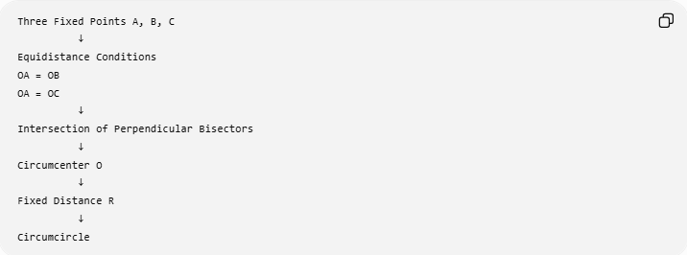
Three Fixed Points A, B, C
↓
Equidistance Conditions
OA = OB
OA = OC
↓
Intersection of Perpendicular Bisectors
↓
Circumcenter O
↓
Fixed Distance R
↓
Circumcircle

Circumcircle of an Acute Triangle
# Source: AI Source: Provided by: [Data Path: Persons Table -> ID Column: 1, Name_En Column: Motasem Essam] -> From: [ChatGPT] on [7/25/2026]
If $△ABC$is acute, the circumcenter lies inside the triangle.
$$\boxed{\text{Acute triangle}→O\text{ inside}}$$
The circumcircle surrounds the entire triangle.
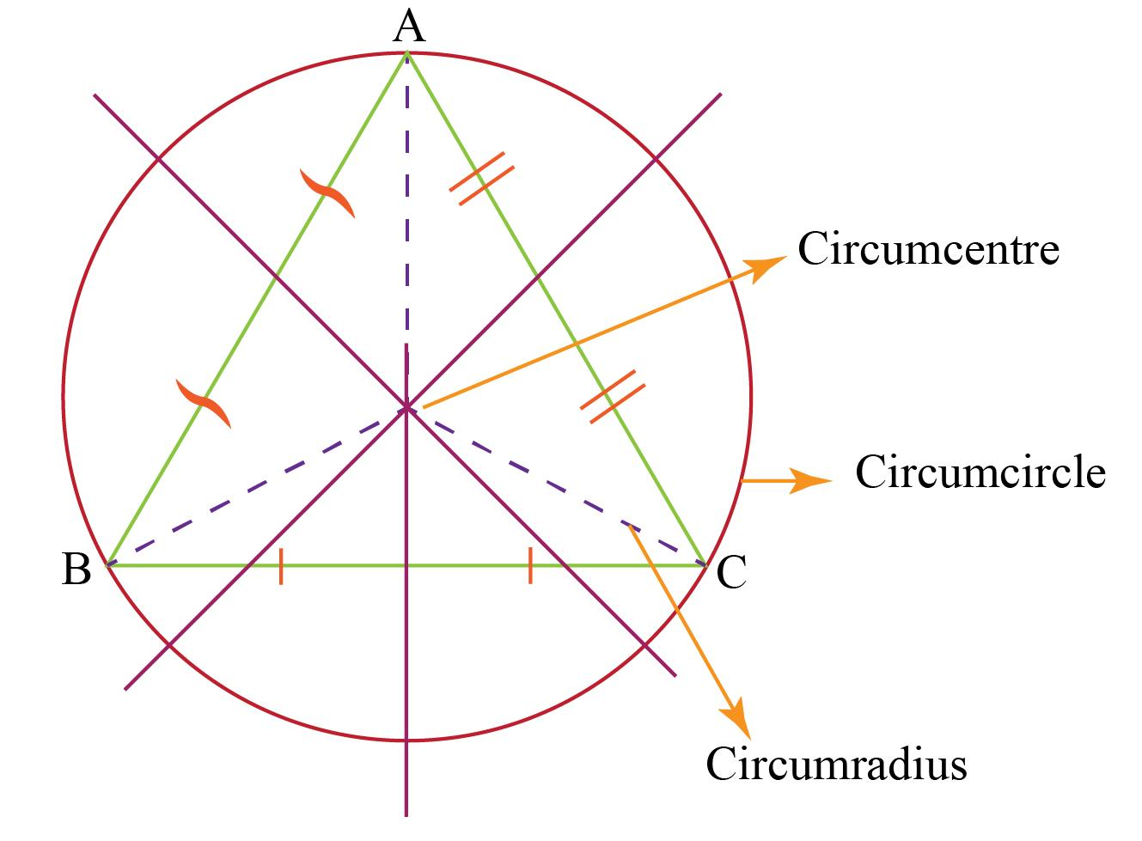
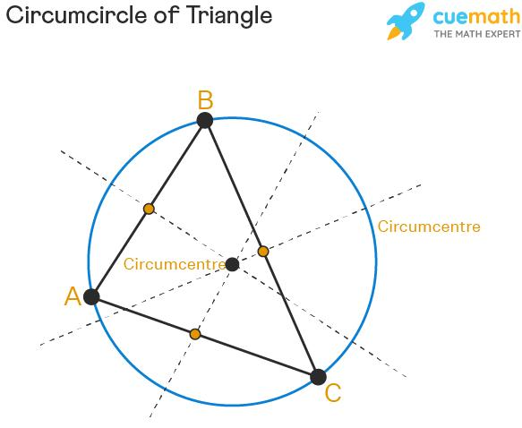
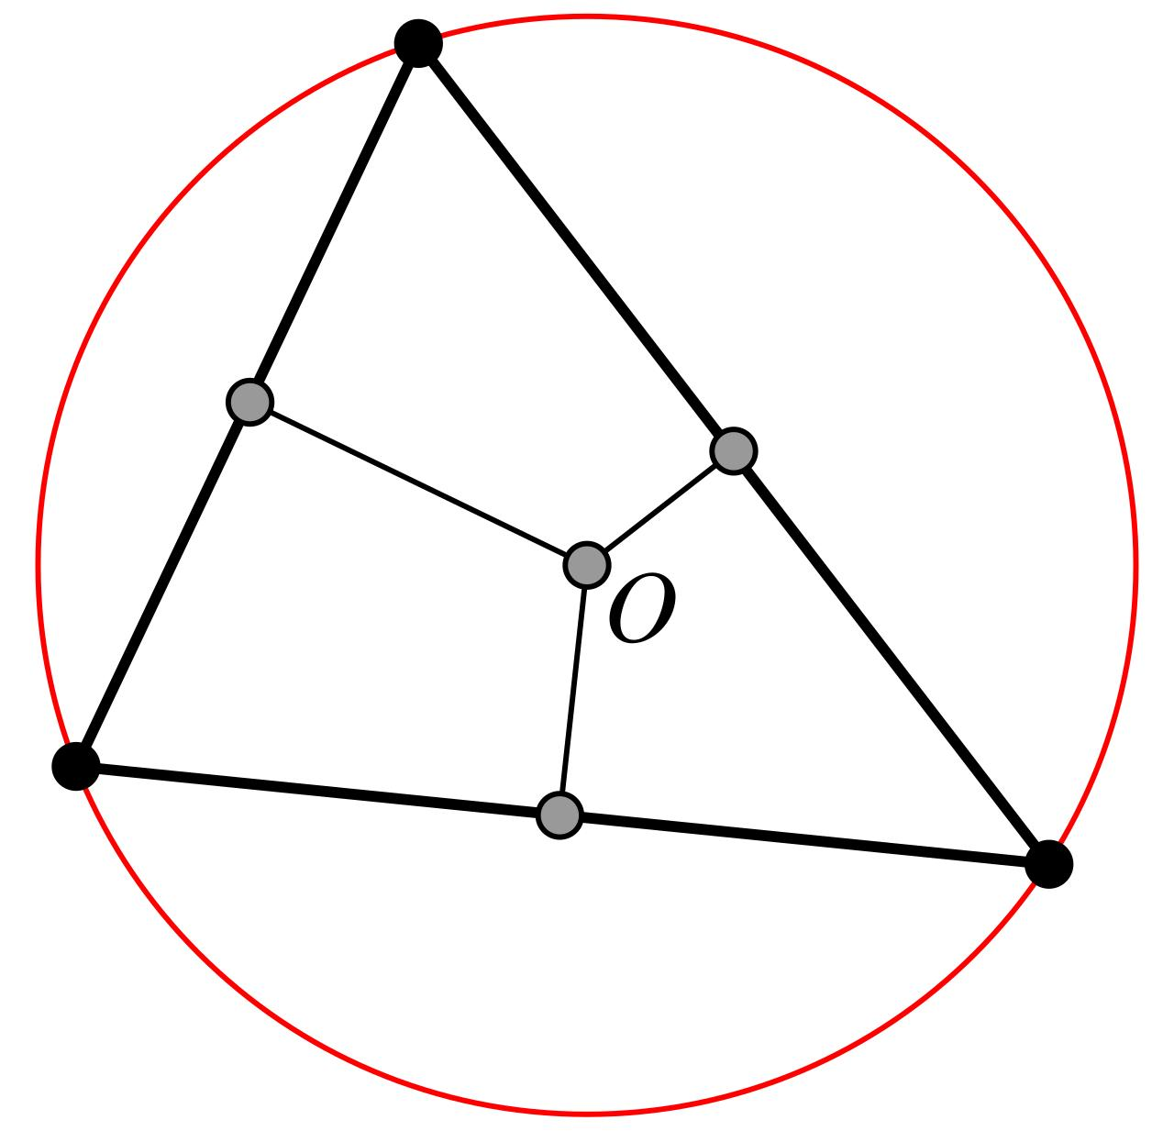
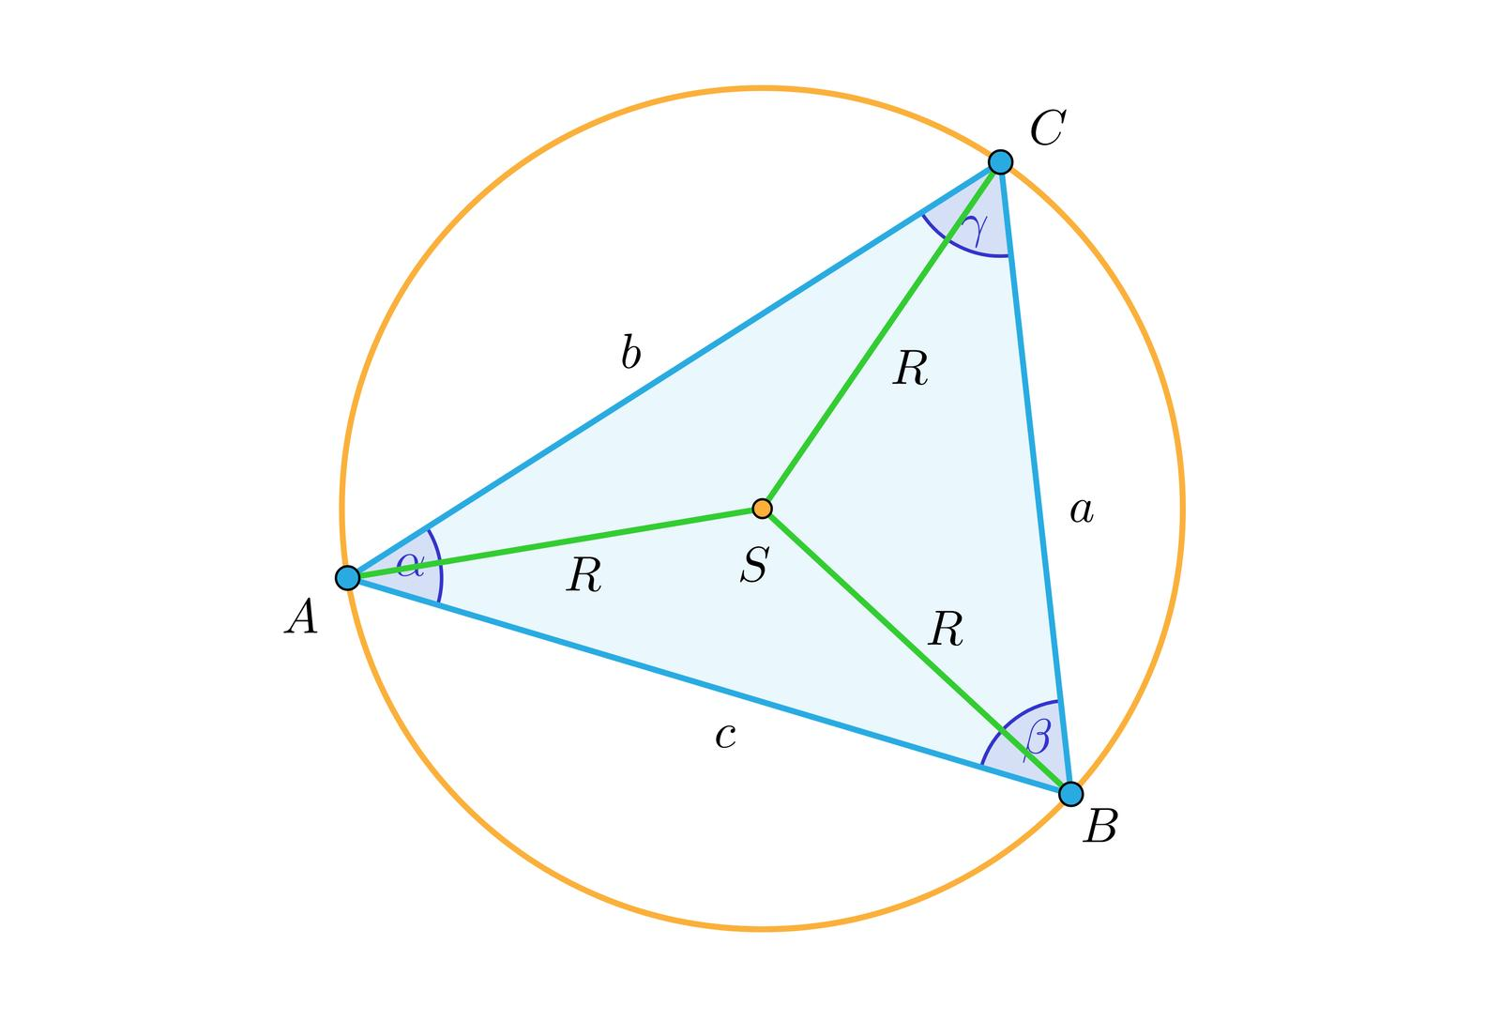

Circumcircle of a Right Triangle
# Source: AI Source: Provided by: [Data Path: Persons Table -> ID Column: 1, Name_En Column: Motasem Essam] -> From: [ChatGPT] on [7/25/2026]
If $△ABC$is right-angled, the circumcenter is the midpoint of the hypotenuse.
Suppose
$$∠C={90}^{∘}.$$
Then $AB$is the hypotenuse, and its midpoint $O$is the circumcenter.
Therefore:
$$\boxed{R=\frac{AB}{2}}.$$
This is a direct consequence of Thales' Theorem.
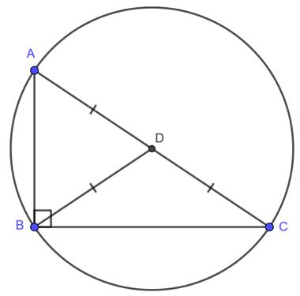
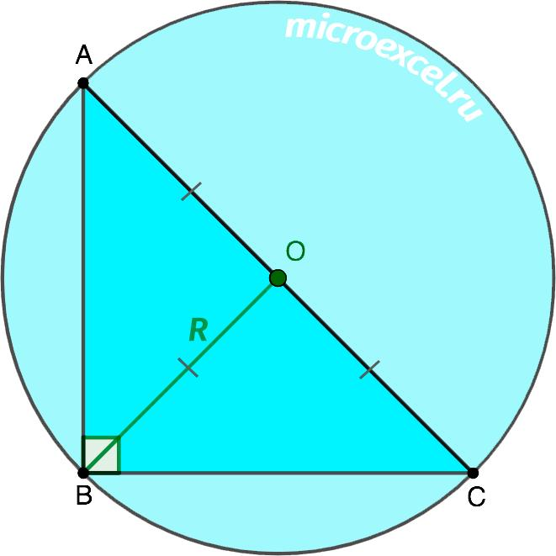
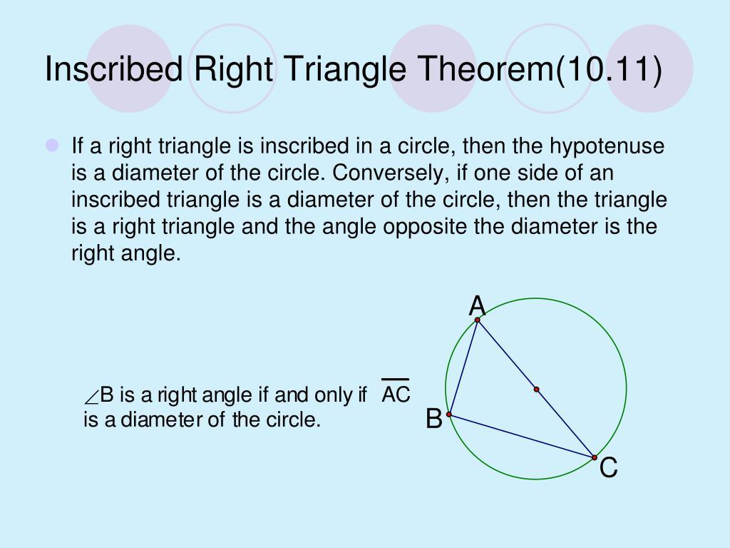
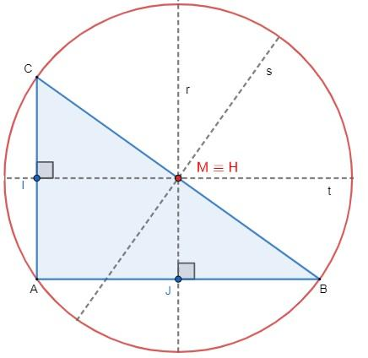

Circumcircle of an Obtuse Triangle
# Source: AI Source: Provided by: [Data Path: Persons Table -> ID Column: 1, Name_En Column: Motasem Essam] -> From: [ChatGPT] on [7/25/2026]
If $△ABC$is obtuse, the circumcenter lies outside the triangle.
$$\boxed{\text{Obtuse triangle}→O\text{ outside}}$$
The circumcircle still passes through all three vertices.
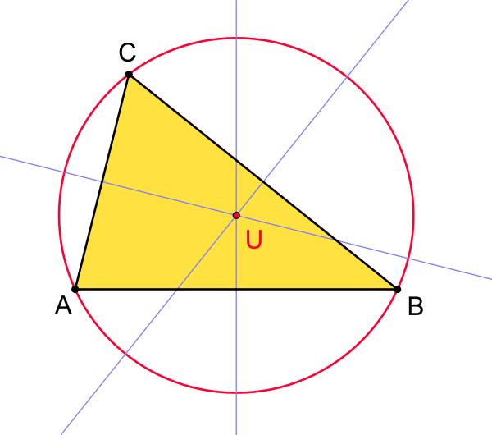
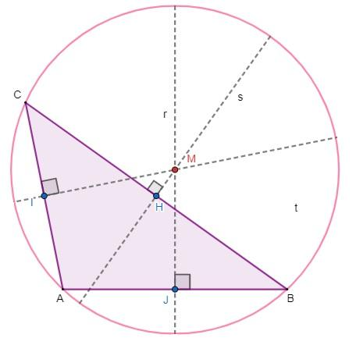
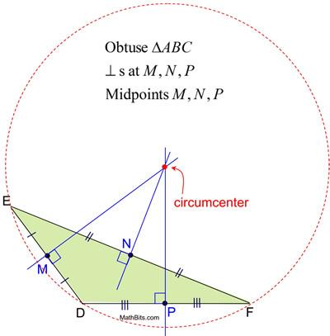
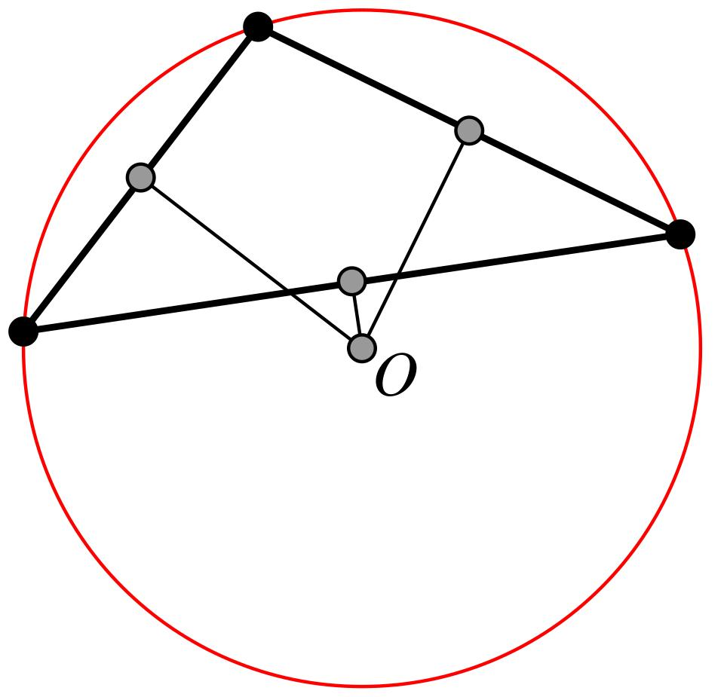
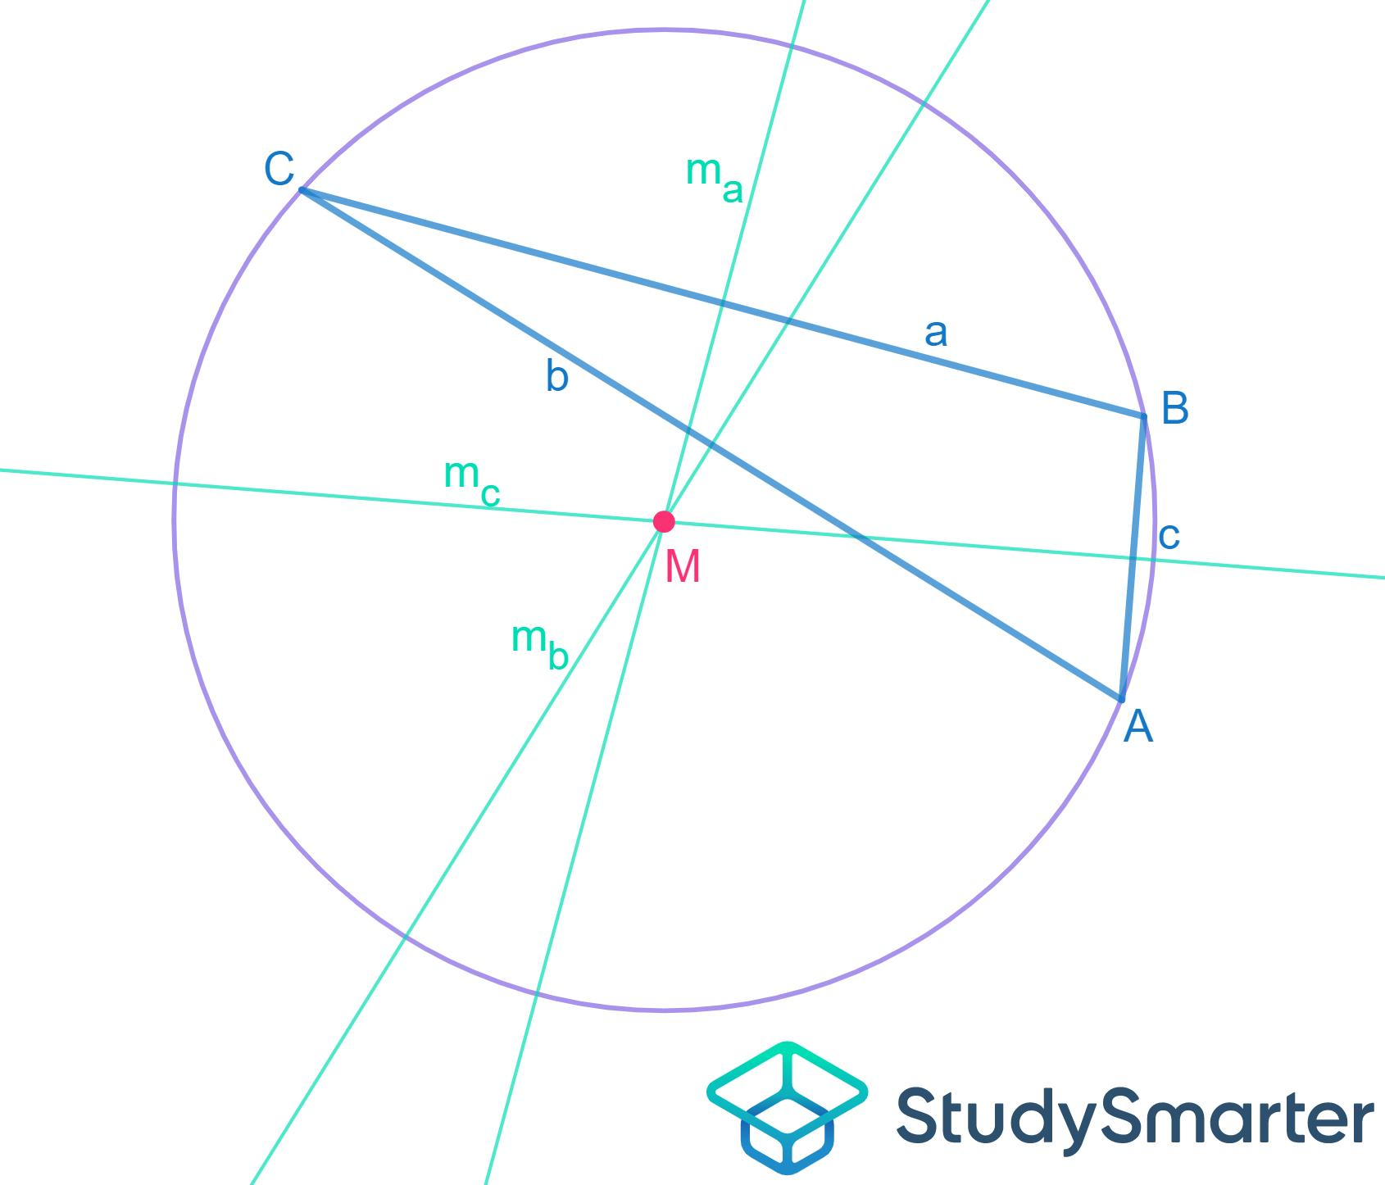

Circumcircle and the Circumradius
# Source: AI Source: Provided by: [Data Path: Persons Table -> ID Column: 1, Name_En Column: Motasem Essam] -> From: [ChatGPT] on [7/25/2026]
The distance from the circumcenter to any vertex is the circumradius:
$$\boxed{R=OA=OB=OC}.$$
For a triangle with side lengths $a,b,c$and area $K$:
$$\boxed{R=\frac{abc}{4K}}$$
where
$$a=BC, b=CA, c=AB.$$
Example
For a $3$-$4$-$5$ right triangle:
$$a=3, b=4, c=5$$
and
$$K=\frac{1}{2}\left(3\right)\left(4\right)=6.$$
Therefore:
$$R=\frac{\left(3\right)\left(4\right)\left(5\right)}{4\left(6\right)} \\ R=\frac{60}{24} \\ \boxed{R=2.5}.$$
This agrees with the fact that the hypotenuse is the diameter:
$$R=\frac{5}{2}.$$

Coordinate Equation of a Circumcircle
# Source: AI Source: Provided by: [Data Path: Persons Table -> ID Column: 1, Name_En Column: Motasem Essam] -> From: [ChatGPT] on [7/25/2026]
If the circumcenter is
$$O=\left(h , k\right)$$
and the circumradius is $R$, then the circumcircle has equation
$$\boxed{{\left(x-h\right)}^{2}+{\left(y-k\right)}^{2}=R^{2}}.$$
Every point $P=\left(x , y\right)$on the circle satisfies
$$OP=R.$$
Example
Suppose the circumcenter is
$$O=\left(3 , 4\right)$$
and
$$R=5.$$
Then:
$$\boxed{{\left(x-3\right)}^{2}+{\left(y-4\right)}^{2}=25}.$$

Circumcircle as a Locus of Points on a Fixed Circle
# Source: AI Source: Provided by: [Data Path: Persons Table -> ID Column: 1, Name_En Column: Motasem Essam] -> From: [ChatGPT] on [7/25/2026]
Once the circumcircle has been determined, it can also be described simply as a membership locus:
$$\boxed{P∈Γ}$$
where $Γ$is the circumcircle.
Thus:
$$\boxed{\text{Locus}=Γ}$$
This is different from saying that the circumcenter is a locus point.
The circumcircle is the set of points satisfying the circle equation; the circumcenter is the fixed point defining the distance condition.

Example
# Source: AI Source: Provided by: [Data Path: Persons Table -> ID Column: 1, Name_En Column: Motasem Essam] -> From: [ChatGPT] on [7/25/2026]
Consider a triangle with vertices
$$A=\left(0 , 0\right), B=\left(6 , 0\right), C=\left(3 , 4\right).$$
The triangle is isosceles because
$$AC=BC=5.$$
The perpendicular bisector of $AB$is
$$x=3.$$
The circumcenter therefore has the form
$$O=\left(3 , k\right).$$
Since
$$OA=OC,$$
we have
$$3^{2}+k^{2}={\left(4-k\right)}^{2}+0^{2}.$$
Thus:
$$9+k^{2}=16-8k+k^{2} \\ 8k=7 \\ k=\frac{7}{8}.$$
Therefore:
$$\boxed{O=\left(3 , \frac{7}{8}\right)}.$$
The circumradius is
$$R=OA=\sqrt{3^{2}+{\left(\frac{7}{8}\right)}^{2}} \\ R=\sqrt{9+\frac{49}{64}} \\ \boxed{R=\frac{\sqrt{625}}{8}=\frac{25}{8}}.$$
Hence the circumcircle is
$$\boxed{{\left(x-3\right)}^{2}+{\left(y-\frac{7}{8}\right)}^{2}=\frac{625}{64}}.$$

Circumcircle and Thales' Theorem
# Source: AI Source: Provided by: [Data Path: Persons Table -> ID Column: 1, Name_En Column: Motasem Essam] -> From: [ChatGPT] on [7/25/2026]
If $AB$is a diameter of the circumcircle, then for every point $P$on the circle:
$$\boxed{∠APB={90}^{∘}}.$$
Therefore, the circumcircle contains the locus of points forming a right angle with the fixed segment $AB$.
This creates an important connection:
$$\boxed{\text{Circumcircle}→\text{Diameter}→\text{Fixed Right-Angle Locus}}$$

Circumcircle and the Perpendicular-Bisector Locus
# Source: AI Source: Provided by: [Data Path: Persons Table -> ID Column: 1, Name_En Column: Motasem Essam] -> From: [ChatGPT] on [7/25/2026]
These two loci work together.
Equidistant from two points
$$PA=PB$$
gives:
$$\boxed{\text{Perpendicular bisector of }AB}.$$
Applying this to the vertices of a triangle:
$$OA=OB$$
and
$$OA=OC.$$
Their intersection gives the circumcenter.
Then:
$$OA=OB=OC=R$$
produces the circumcircle.
Thus:
$$\boxed{\text{Perpendicular-Bisector Loci}→\text{Circumcenter}→\text{Circumcircle}}$$

Circumcircle vs Incircle
# Source: AI Source: Provided by: [Data Path: Persons Table -> ID Column: 1, Name_En Column: Motasem Essam] -> From: [ChatGPT] on [7/25/2026]
These two should not be confused.
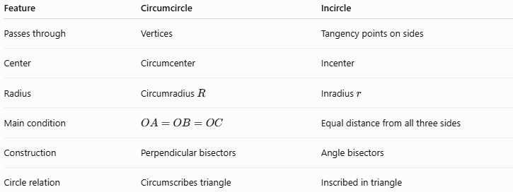
Feature | Circumcircle | Incircle
Passes through | Vertices | Tangency points on sides
Center | Circumcenter | Incenter
Radius | Circumradius $R$ | Inradius $r$
Main condition | $$OA=OB=OC$$ | Equal distance from all three sides
Construction | Perpendicular bisectors | Angle bisectors
Circle relation | Circumscribes triangle | Inscribed in triangle
The circumcircle is associated with equal distances from vertices.
The incircle is associated with equal distances from sides.

Circumcircle vs Fixed-Distance Locus
# Source: AI Source: Provided by: [Data Path: Persons Table -> ID Column: 1, Name_En Column: Motasem Essam] -> From: [ChatGPT] on [7/25/2026]
A general fixed-distance locus is:
$$OP=R.$$
The circumcircle is a particular application:
$$\boxed{OA=OB=OC=R}$$
and therefore $A,B,C$are points on the fixed-distance circle centered at $O$.
So:
$$\boxed{\text{Circumcircle}⊂\text{Fixed-Distance Circle Loci}}$$
More precisely, the circumcircle is a fixed-distance circle whose radius is the circumradius of the triangle.

Classification
# Source: AI Source: Provided by: [Data Path: Persons Table -> ID Column: 1, Name_En Column: Motasem Essam] -> From: [ChatGPT] on [7/25/2026]
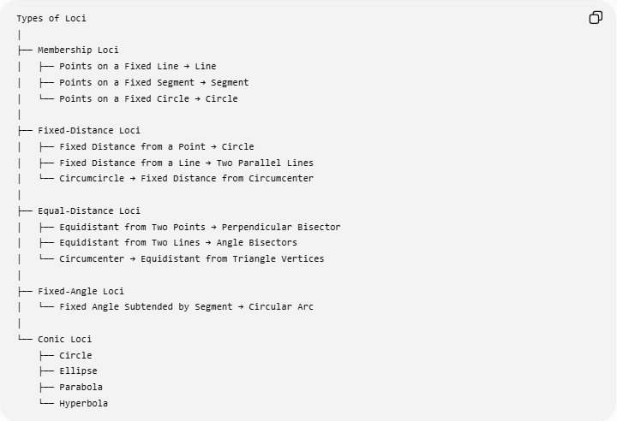
Types of Loci
│
├── Membership Loci
│ ├── Points on a Fixed Line → Line
│ ├── Points on a Fixed Segment → Segment
│ └── Points on a Fixed Circle → Circle
│
├── Fixed-Distance Loci
│ ├── Fixed Distance from a Point → Circle
│ ├── Fixed Distance from a Line → Two Parallel Lines
│ └── Circumcircle → Fixed Distance from Circumcenter
│
├── Equal-Distance Loci
│ ├── Equidistant from Two Points → Perpendicular Bisector
│ ├── Equidistant from Two Lines → Angle Bisectors
│ └── Circumcenter → Equidistant from Triangle Vertices
│
├── Fixed-Angle Loci
│ └── Fixed Angle Subtended by Segment → Circular Arc
│
└── Conic Loci
├── Circle
├── Ellipse
├── Parabola
└── Hyperbola

Key Formulas
# Source: AI Source: Provided by: [Data Path: Persons Table -> ID Column: 1, Name_En Column: Motasem Essam] -> From: [ChatGPT] on [7/25/2026]
Equal distances from vertices
$$\boxed{OA=OB=OC}$$
Circumradius
$$\boxed{R=OA=OB=OC}$$
Circumcircle equation
$$\boxed{{\left(x-h\right)}^{2}+{\left(y-k\right)}^{2}=R^{2}}$$
Circumradius from sides and area
$$\boxed{R=\frac{abc}{4K}}$$
Right triangle
$$\boxed{R=\frac{\text{hypotenuse}}{2}}$$
Inscribed-angle relationship
$$\boxed{m∠APB=\frac{1}{2}m\hat{AB}}$$

Classification Summary
# Source: AI Source: Provided by: [Data Path: Persons Table -> ID Column: 1, Name_En Column: Motasem Essam] -> From: [ChatGPT] on [7/25/2026]
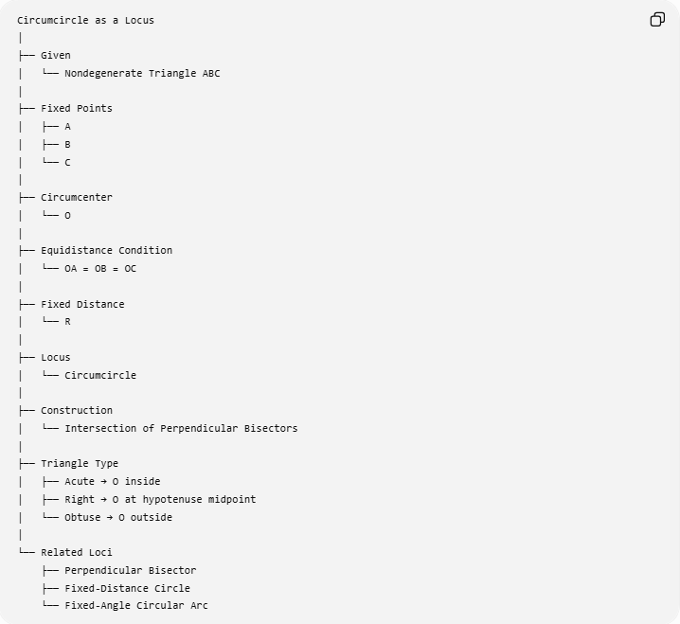
Circumcircle as a Locus
│
├── Given
│ └── Nondegenerate Triangle ABC
│
├── Fixed Points
│ ├── A
│ ├── B
│ └── C
│
├── Circumcenter
│ └── O
│
├── Equidistance Condition
│ └── OA = OB = OC
│
├── Fixed Distance
│ └── R
│
├── Locus
│ └── Circumcircle
│
├── Construction
│ └── Intersection of Perpendicular Bisectors
│
├── Triangle Type
│ ├── Acute → O inside
│ ├── Right → O at hypotenuse midpoint
│ └── Obtuse → O outside
│
└── Related Loci
├── Perpendicular Bisector
├── Fixed-Distance Circle
└── Fixed-Angle Circular Arc

Key Points
# Source: AI Source: Provided by: [Data Path: Persons Table -> ID Column: 1, Name_En Column: Motasem Essam] -> From: [ChatGPT] on [7/25/2026]
- The circumcircle passes through all three vertices of a triangle.
- Its center is the circumcenter.
- The circumcenter satisfies
$$OA=OB=OC.$$
- The common distance is the circumradius $R$.
- Therefore, the circumcircle is a fixed-distance locus:
$$\boxed{OP=R}.$$
- The circumcenter is found by intersecting perpendicular bisectors.
- An acute triangle has its circumcenter inside.
- A right triangle has its circumcenter at the midpoint of its hypotenuse.
- An obtuse triangle has its circumcenter outside.
- The circumcircle is closely related to fixed-angle loci through the Inscribed Angle Theorem.
- The circumcircle should not be confused with the incircle.

Conclusion
# Source: AI Source: Provided by: [Data Path: Persons Table -> ID Column: 1, Name_En Column: Motasem Essam] -> From: [ChatGPT] on [7/25/2026]
The Circumcircle as a Locus is the circle determined by the three vertices of a triangle. From the locus viewpoint, it is the set of all points at the fixed distance $R$from the circumcenter $O$:
$$\boxed{\text{Circumcircle}=\left\{P:OP=R\right\}}$$
The circumcenter itself is obtained from the equal-distance conditions
$$\boxed{OA=OB=OC},$$
which are found through the perpendicular-bisector loci of the triangle's sides.
Thus, the fundamental relationship is:
$$\boxed{\text{Equidistance from Triangle Vertices}→\text{Circumcenter}→\text{Fixed-Distance Circle}→\text{Circumcircle}}$$

